|  |  |
| --- | --- |
|  | **Nandini Rajeswaran**  **Parvathivarma Ramar(W1284667)**  **Priyanka Nirpase(W1356392)** |

INTRODUCTION

For organizations, most valuable asset is their human capital. The skills, qualifications, training levels and productivity of a workforce can make or break a company. Companies dedicate more resources for recruiting, training and maintaining teams of talented professionals. This project Human Capital Management system automates mundane activities and bring them under one umbrella in order to achieve faster performance with great quality.

BUSINESS APPLICATION

A Human Capital Management System(HCM) helps to revolutionize a workplace and provide a modern approach to the HR activities. The function of the HRMS application is to perform specific function for each module which helps with information gathering and tracking. HRMS modules can assist with

* Managing the payroll
* Recruitment and onboarding
* Performance evaluation
* Benefits Administration
* [Keeping attendance records](http://www.hrpayrollsystems.net/time-and-attendance-software/) and tracking absenteeism
* Learning Management
* Analytics and informed decision making

BUSINESS VALUE

HCM system automates mundane activities and bring them under one umbrella in order to achieve faster performance with great quality. It also effectively manages Benefits Administration, Payroll, map out succession planning for project allocations.

ACTORS

USE CASES

## **HR ADMIN**

* On recruitment, HR updates the information into the employee database and assign the project team based on the skillset of the employee and project demand.
* He runs report to track the attendance of the employee and record the absence information which will be used by Payroll admin for processing payroll.
* Based on the information provided by the project manager, HR can update the salary hike details.
* HR can retrieve the details of the employee to forecast the necessary onboarding or layoff activities to the company.

## **EMPLOYEES**

* Employee can view his profile, manager assigned and update information if required.
* Employee can view his salary records using the system. In case of any discrepancy, he/she can view his salary breakdown, view his absent record and raise a complaint to Human Resource Team.
* Employee can request and apply for leave in the system and the leave request will be automatically forwarded to Project manager.
* Employee will be notified of his/her project team along with the project allocation start date and end date.

## **PROJECT MANAGER**

* Manager can review employee profile and request project allocation for the particular employee.
* He will be able to generate reports for performance review and declare bonus/awards based on performance.
* He will be able to manage employee leaves.

## **ANALYST**

* Analyst will collate HR, Payroll, absence and performance data. He will try to find out trends in this data.
* Based on resignation data, he will analyze which factor lead to most of the resignations.
* He will analyze how much average time is needed to fill a particular position in a database.
* Based on historical data, he will figure out the best referral source to seek the talent pool.
* He will find trends in other metrics such as utilization per project, salary expenses, etc.

QUERIES FOR EACH TYPE OF USER

## **HR ADMIN**

* Inserts the employee information into the EMPLOYEE table.
* Inserts project details on to the Project and Works table.
* Updates Project End Date and Start Date information in the Project table.
* Updates the Compensation Rate based on the information in the Performance table.
* Search for employees with Project end date for future allocation into projects.

## **EMPLOYEES**

* Select and view employee information
* Update the personal information for any change (Eg: Address update)
* Select and view the project allocations over the time.
* Select and view the performance review update in the performance table.
* Select and view his pay data, earning and deduction information
* Inserts the detail of the leave request for the Absence table.

## **PROJECT MANAGER**

* Select and view the employees allocated to the project.
* Updates required head count based on the project requirements in the project role.
* Search for the employee who has details in the absence details.

## **PAYROLL ADMIN**

* Select and view demographic and payroll data which is required for processing payroll.
* Manipulate and update the employee’s total earnings based on the hours worked.
* Manipulate and update the employee’s tax and benefit deductions based on their enrollment.
* Process and update the payroll data in to the Pay data table.

BUSINESS METRICS

## **1. Time to fill position**

* Find out the date at which manager requested for a resource
* Find out the date at which the resource was allocated
* More efficient when the difference between the two is less

## **2. Absent Rate**

* Project/department wise analysis of absenteeism
* Deep dive into the reason for high leave application

## **3. Best Referral source**

* Find out the most effective and least effective source
* Invest depending on the effectiveness

## **4. Reason for Resignation**

* Analysis the reason for the resignation and find solution to reduce the attrition rate

## **5. Utilization**

* Find out how effectively employees perform based on the total hours worked and the standard hours allocated for each employee

## **6. Salary Expense**

* Find out the Staffing costs to manage the financial budget on Human Resources
* To analyze and process bonus and compensation pay calculations

Conceptual Model

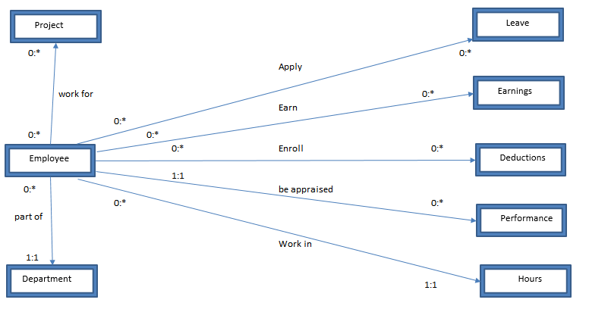

Logical Model

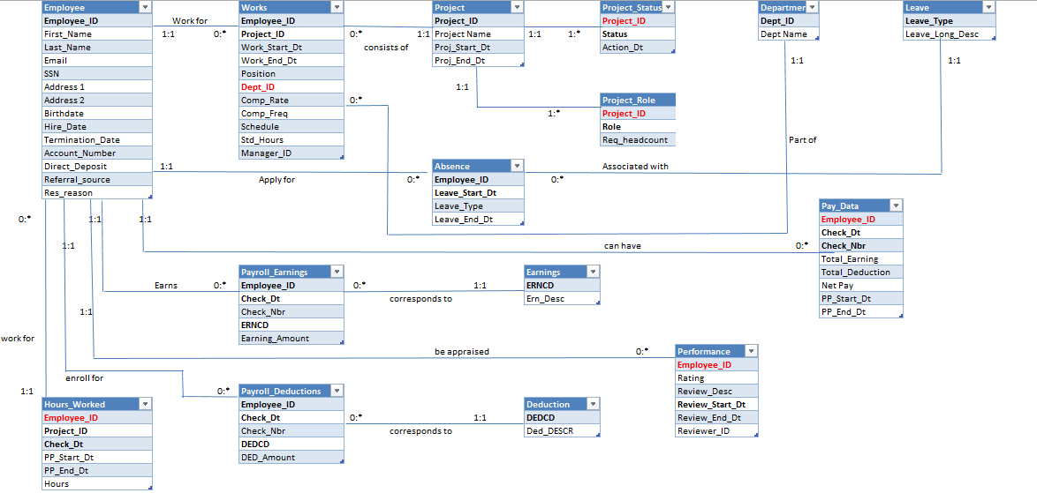

Physical Model/Data Dictionary

|  |  |  |  |
| --- | --- | --- | --- |
| **Employee** | **Datatype** | **Constraint** |  |
| **Employee_ID** | **INT (Auto)** | **NOT NULL** |  |
| First_Name | Varchar (20) | NOT NULL |  |
| Last_Name | Varchar (20) |  |  |
| Email | Varchar (20) |  |  |
| SSN | Varchar (10) | NOT NULL |  |
| Address 1 | Varchar (50) |  |  |
| Address 2 | Varchar (50) |  |  |
| Birthdate | Date |  |  |
| Hire_Date | Date |  |  |
| Termination_Date | Date |  |  |
| Account_Number | Varchar (20) |  | //Bank accnt# for depositing salary |
| Direct_Deposit | Varchar (5) |  | // Y or N, if Y then populate account number |
| Referral_source | Varchar (50) |  | //Facebook, LinkedIn, Agent, Classifieds, Employee |
| Res_reason | Varchar (50) |  | //Reason for resignation |

|  |  |  |  |
| --- | --- | --- | --- |
| **Project** | **Datatype** | **Constraint** |  |
| **Project_ID** | **Varchar (20)** | **NOT NULL** | //PROJ-SONY, PROJ-MICROSOFT |
| Project Name | Varchar (50) |  | //Project for client Sony |
| Proj_Start_Dt | Timestamp |  |  |
| Proj_End_Dt | Timestamp |  |  |

|  |  |  |  |
| --- | --- | --- | --- |
| **Project_Status** | **Datatype** | **Constraint** |  |
| **Project_ID** | **Varchar (20)** | **NOT NULL** |  |
| **Status** | Varchar (10) | NOT NULL | //Active, Closed, Waiting |
| Action_Dt | Date |  | //Date on which status changes |

|  |  |  |  |
| --- | --- | --- | --- |
| **Works** | **Datatype** | **Constraint** |  |
| **Employee_ID** | **INT** | **NOT NULL** | //FK from Employee (Employee ID) |
| **Project_ID** | **Varchar (20)** | **NOT NULL** | //FK from Project (Project ID) |
| Work_Start_Dt | Timestamp | NOT NULL | //Date on which employee |
| Work_End_Dt | Timestamp |  | //starts work in the project |
| Position | Varchar (20) |  | //FK from Emp_Job(Position) |
| **Dept_ID** | Varchar (10) |  | //FK from Department(Dept_ID) |
| Comp_Rate | Varchar (20) |  | //Pay rate |
| Comp_Freq | Varchar (20) |  | //Weekly, Hourly |
| Schedule | Varchar (10) |  | //Full time, Part-time |
| Std_Hours | Numeric (5,2) |  | //40.00, 20.00 |
| Manager_ID | INTEGER |  |  |

|  |  |  |  |
| --- | --- | --- | --- |
| **Project_Role** | **Datatype** | **Constraint** |  |
| **Project_ID** | **Varchar (20)** | **NOT NULL** | //FK from Project(Project_ID) |
| **Role** | **Varchar (20)** | **NOT NULL** | //Analyst, Developer, Project Manager |
| Req_headcount | Number(3) |  | //Number of employees required for each role |

|  |  |  |  |
| --- | --- | --- | --- |
| **Absence** | **Datatype** | **Constraint** |  |
| **Employee_ID** | **INT** | **NOT NULL** | //FK from Employee (Employee ID) |
| **Leave_Start_Dt** | **Timestamp** | **NOT NULL** |  |
| Leave_Type | Varchar (10) |  | //FK from Leave (Leave_Type) |
| Leave_End_Dt | Timestamp |  |  |

|  |  |  |  |
| --- | --- | --- | --- |
| **Leave** | **Datatype** | **Constraint** |  |
| **Leave_Type** | **Varchar (10)** | **NOT NULL** | //SICK, FML,JRY,BRV |
| Leave_Long_Desc | Varchar (50) |  | //SICK,Family,Jury Duty |

|  |  |  |  |
| --- | --- | --- | --- |
| **Hours_Worked** | **Datatype** | **Constraint** |  |
| **Employee_ID** | **INT** | **NOT NULL** | //FK from Employee (Employee ID) |
| **Project_ID** | **Varchar (20)** | **NOT NULL** |  |
| **Check_Dt** | **Date** | **NOT NULL** |  |
| PP_Start_Dt | **Date** |  |  |
| PP_End_Dt | **Date** |  | //Actual hours worked |
| Hours | Numeric (5,2) |  |  |

|  |  |  |  |
| --- | --- | --- | --- |
| **Payroll_Earning** | **Datatype** | **Constraint** |  |
| **Employee_ID** | **INT** | **NOT NULL** | //FK from Employee (Employee ID) |
| **Check_Dt** | **Date** | **NOT NULL** |  |
| Check_Nbr | Varchar (20) | NOT NULL | //FK from Earnings (ERNCD) |
| **ERNCD** | **Varchar (10)** | **NOT NULL** |  |
| Earning_Amount | Numeric (10,2) |  |  |

|  |  |  |  |
| --- | --- | --- | --- |
| **Earning** | **Datatype** | **Constraint** |  |
| **ERNCD** | **Varchar (10)** | **NOT NULL** | //BN,REG,OT |
| Ern_Desc | Varchar (20) |  | //BONUS,Regular,Overtime |

|  |  |  |  |
| --- | --- | --- | --- |
| **Deduction** | **Datatype** | **Constraint** |  |
| **DEDCD** | **Varchar (10)** | **NOT NULL** | //TAX,MED,DEN,401k |
| Ded_DESC | Varchar (20) |  | //Tax,Medical,Dental,401k |

|  |  |  |  |
| --- | --- | --- | --- |
| **Payroll_Deduction** | **Datatype** | **Constraint** |  |
| **Employee_ID** | **INT** | **NOT NULL** | //FK from Employee (Employee ID) |
| **Check_Dt** | **Date** | **NOT NULL** |  |
| Check_Nbr | Varchar (20) | NOT NULL |  |
| **DEDCD** | **Varchar (10)** | **NOT NULL** | //FK from Deduction (DEDCD) |
| DED_Amount | Numeric (10,2) |  |  |

|  |  |  |  |
| --- | --- | --- | --- |
| **Performance** | **Datatype** | **Constraint** |  |
| **Employee_ID** | **INT** | **NOT NULL** | //FK from Employee (Employee ID) |
| Rating | Varchar (5) | NOT NULL | //9.0,5.0 |
| Review_Desc | Varchar (100) | NOT NULL | //FPR-2016, FPR-2017 |
| **Review_Start_Dt** | **Date** | **NOT NULL** | //Review Period Start date |
| Review_End_Dt | Date |  |  |
| Reviewer_ID | INT | NOT NULL |  |

|  |  |  |  |
| --- | --- | --- | --- |
| **Pay_Data** | **Datatype** | **Constraint** |  |
| **Employee_ID** | **INT** | **NOT NULL** | //FK from Employee (Employee ID) |
| **Check_Dt** | **Date** | **NOT NULL** |  |
| **Check_Nbr** | **Varchar (20)** | **NOT NULL** |  |
| Total_Earning | Numeric (10,2) |  | //Total Earning - Total Deduction |
| Total_Deduction | Numeric (10,2) |  |  |
| Net_Pay | Numeric (10,2) |  |  |
| PP_Start_Dt | Date | NOT NULL | //Start date of the week for which paycheck is produced |
| PP_End_Dt | Date |  |  |

Data Domain Values

|  |
| --- |
| **Emoployee.Direct_Deposit** |
| Y |
| N |

|  |
| --- |
| **Employee.Referral_source** |
| Linkedin |
| on-campus |
| Classifieds |
| Employee |
| Others |

|  |
| --- |
| **Works.schedule** |
| Full-Time |
| Part-Time |

|  |
| --- |
| **Works.Position** |
| Project Manager |
| Developer |
| System Analyst |
| Digital Marketing Executive |
| Business Analyst |

|  |
| --- |
| **Dept.Dept_ID** |
| HR |
| IT |
| MKT |
| SL |
| **Project_Role.Role** |
| Project Manager |
| Developer |
| System Analyst |
| Digital Marketing Executive |
| Business Analyst |

|  |
| --- |
| **Project_Status.Status** |
| Active |
| Closed |
| Waiting |

|  |
| --- |
| **Leave.Leave_Type** |
| Sick-Sick Leave |
| FML-Family Medical |
| JURY-Jury Duty |
| BRV-Bereavment |
| UPO-Unpaid Off |

|  |
| --- |
| **Earning.ERNCD** |
| REG |
| OT |
| BN |
| BNF |

|  |
| --- |
| **Deduction.DEDCD** |
| TAX |
| 401k |
| MED |
| DEN |
| VIS |

|  |
| --- |
| **Performance.Rating** |
| 1 |
| 2 |
| 3 |
| 4 |
| 5 |

Data Definition Language(DDL) Queries

## **Employee**

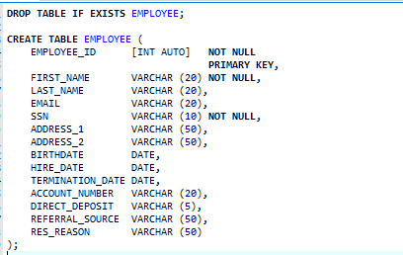

## **Project**

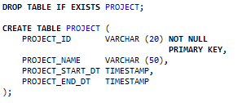

## **Department**

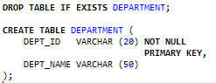

## **Works**

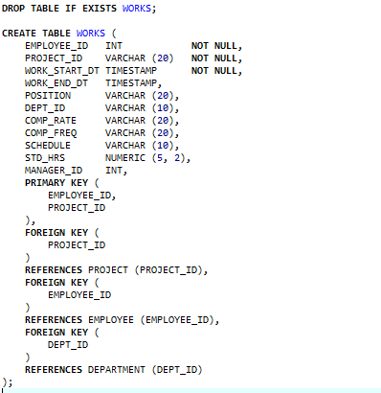

## **Project_Role**

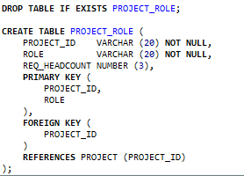

## **Project_Status**

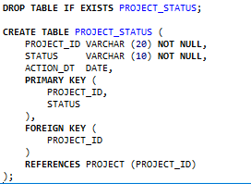

## **Performance**

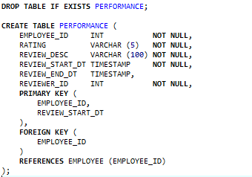

## **Leave**

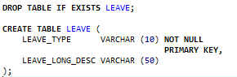

## **Earning**

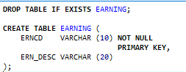

## **Deduction**

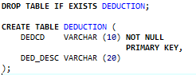

## **Hours_Worked**

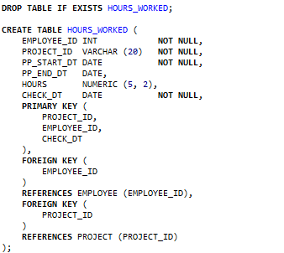

## **Absence**

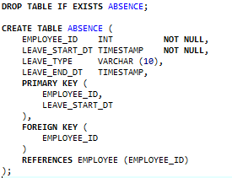

## **Payroll_Earning**

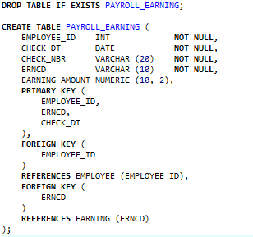

## **Payroll_deduction**

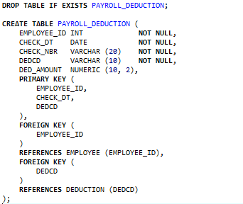

## **Pay_Data**

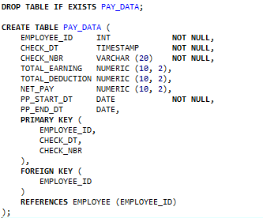

INDEXES

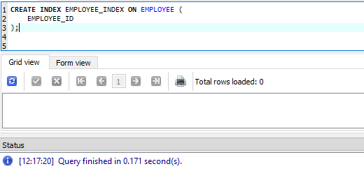

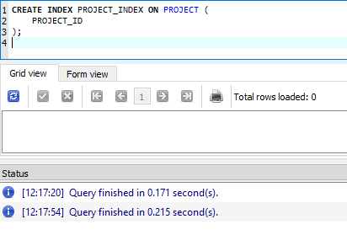

VIEWS

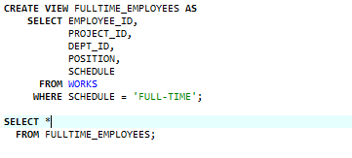



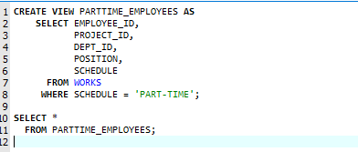



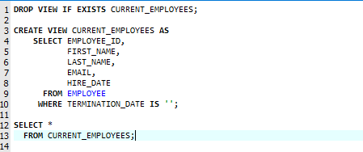



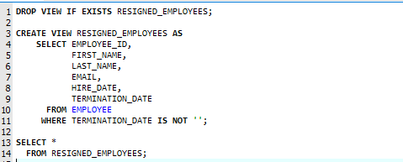



Trigger

Delete employees whose termination date is less than (SYSDATE - 3 years)

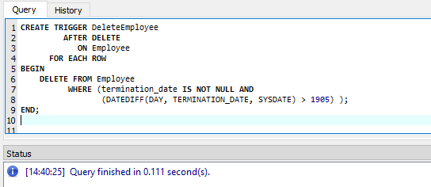

Insert Queries

* INSERT INTO EMPLOYEE (EMPLOYEE_ID,FIRST_NAME,LAST_NAME,EMAIL,SSN,ADDRESS_1,ADDRESS_2,BIRTHDATE,HIRE_DATE,TERMINATION_DATE,ACCOUNT_NUMBER,DIRECT_DEPOSIT,REFERRAL_SOURCE,RES_REASON) VALUES (100,'ALISHA','AZAAN','ALISHAAZAAN@DN.COM','738393934','25313 OAK DR, DAMASCUS','CA 94043','1987-09-14','2017-03-20','','628336','Y','LINKEDIN','');
* INSERT INTO PROJECT(PROJECT_ID,PROJECT_NAME,PROJECT_START_DT,PROJECT_END_DT)VALUES('SONY-CM','PROJECT TO CREATE AND LAUNCH CS21 CAMPAIGN ','2017-04-20','2017-07-26');
* INSERT INTO DEPARTMENT (DEPT_ID, DEPT_NAME) VALUES('HR','HUMAN RESOURCE');
* INSERT INTO WORKS(EMPLOYEE_ID,PROJECT_ID,WORK_START_DT,WORK_END_DT,POSITION,DEPT_ID,COMP_RATE,COMP_FREQ,SCHEDULE,STD_HRS,MANAGER_ID) VALUES(100,'SONY-CM','2017-04-26','2017-07-26','PROJECT MANAGER','IT','10800','MONTHLY','FULL-TIME','40','');
* INSERT INTO PROJECT_ROLE(PROJECT_ID, ROLE,REQ_HEADCOUNT) VALUES('SONY-CM','SYSTEM ANALYST',2);
* INSERT INTO PROJECT_STATUS(PROJECT_ID,STATUS,ACTION_DT) VALUES('SONY-CM','WAITING','2017-04-20');
* INSERT INTO PERFORMANCE(EMPLOYEE_ID,RATING,REVIEW_DESC,REVIEW_START_DT,REVIEW_END_DT,REVIEWER_ID)VALUES(101,3,'CONSISTENT BUT NEEDS MORE IMPROVEMENT','2017-05-01','2017-05-12',100);
* INSERT INTO LEAVE(LEAVE_TYPE,LEAVE_LONG_DESC) VALUES ('SICK','SICK LEAVE');
* INSERT INTO EARNING(ERNCD,ERN_DESC) VALUES ('BN','BONUS');
* INSERT INTO DEDUCTION(DEDCD,DED_DESC) VALUES ('TAX','TOTAL TAXES');
* INSERT INTO HOURS_WORKED(PROJECT_ID,EMPLOYEE_ID,PP_START_DT,PP_END_DT,HOURS,CHECK_DT) VALUES ('SONY-CM',100,'2017-05-01','2017-05-31',32,'2017-05-31');
* INSERT INTO ABSENCE(EMPLOYEE_ID,LEAVE_START_DT,LEAVE_TYPE,LEAVE_END_DT) VALUES('102','2017-05-21','SICK','2017-05-22');
* INSERT INTO PAYROLL_EARNING(EMPLOYEE_ID,CHECK_DT,CHECK_NBR,ERNCD,EARNING_AMOUNT) VALUES (100,'2017-05-31',456789,'REG',10800);
* INSERT INTO PAYROLL_DEDUCTION(EMPLOYEE_ID,CHECK_DT,CHECK_NBR,DEDCD,DED_AMOUNT) VALUES (100,'2017-05-31',456789,'MED',500);
* INSERT INTO PAY_DATA(EMPLOYEE_ID,CHECK_DT,CHECK_NBR,TOTAL_EARNING,TOTAL_DEDUCTION,NET_PAY,PP_START_DT,PP_END_DT) VALUES (100,'2017-05-31',456789,11200,600,10600,'2017-05-01','2017-05-31');

SELECT QUERIES

## **1. EMPLOYEE**

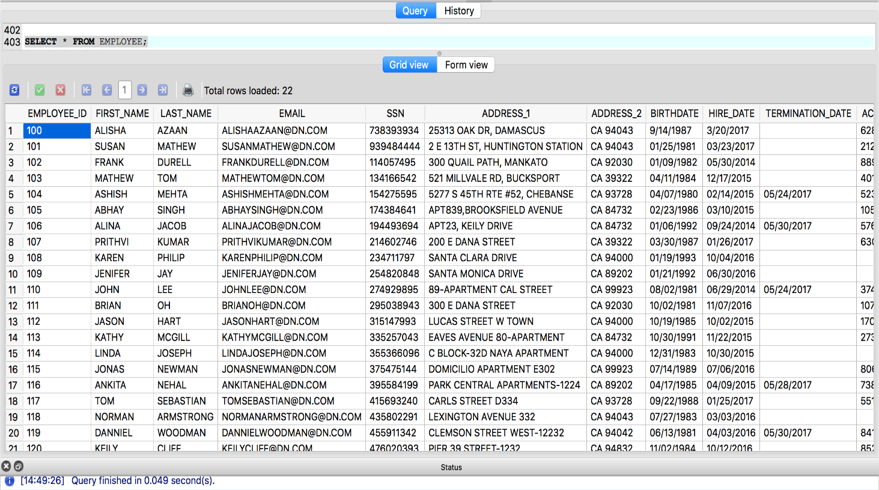

Detailed view of the EMPLOYEE Table

|  |  |  |  |  |  |  |  |  |  |  |  |  |  |
| --- | --- | --- | --- | --- | --- | --- | --- | --- | --- | --- | --- | --- | --- |
| EMPLOYEE_ID | FIRST_NAME | LAST_NAME | EMAIL | SSN | ADDRESS_1 | ADDRESS_2 | BIRTHDATE | HIRE_DATE | TERMINATION_DATE | ACC NO | DIRECT DEPOSIT | REFERRAL_SOURCE | RESIGNATION_REASON |
| 100 | ALISHA | AZAAN | ALISHAAZAAN@DN.COM | 738393934 | 25313 OAK DR, DAMASCUS | CA 94043 | 9/14/1987 | 3/20/2017 |  | 628336 | Y | LINKEDIN |  |
| 101 | SUSAN | MATHEW | SUSANMATHEW@DN.COM | 939484444 | 2 E 13TH ST, HUNTINGTON STATION | CA 94043 | 01/25/1981 | 03/23/2017 |  | 212540 | Y | LINKEDIN |  |
| 102 | FRANK | DURELL | FRANKDURELL@DN.COM | 114057495 | 300 QUAIL PATH, MANKATO | CA 92030 | 01/09/1982 | 05/30/2014 |  | 889731 | Y | INDEED |  |
| 103 | MATHEW | TOM | MATHEWTOM@DN.COM | 134166542 | 521 MILLVALE RD, BUCKSPORT | CA 39322 | 04/11/1984 | 12/17/2015 |  | 401631 | Y | ON-CAMPUS |  |
| 104 | ASHISH | MEHTA | ASHISHMEHTA@DN.COM | 154275595 | 5277 S 45TH RTE #52, CHEBANSE | CA 93728 | 04/07/1980 | 02/14/2015 | 05/24/2017 | 523865 | Y | ON-CAMPUS | BETTER PAY |
| 105 | ABHAY | SINGH | ABHAYSINGH@DN.COM | 174384641 | APT839,BROOKSFIELD AVENUE | CA 84732 | 02/23/1986 | 03/10/2015 |  | 105987 | Y | LINKEDIN |  |
| 106 | ALINA | JACOB | ALINAJACOB@DN.COM | 194493694 | APT23, KEILY DRIVE | CA 84732 | 01/06/1992 | 09/24/2014 | 05/30/2017 | 576256 | Y | EMPLOYEE | HIGHER STUDIES |
| 107 | PRITHVI | KUMAR | PRITHVIKUMAR@DN.COM | 214602746 | 200 E DANA STREET | CA 39322 | 03/30/1987 | 01/26/2017 |  | 630929 | Y | EMPLOYEE |  |
| 108 | KAREN | PHILIP | KARENPHILIP@DN.COM | 234711797 | SANTA CLARA DRIVE | CA 94000 | 01/19/1993 | 10/04/2016 |  |  | N | EMPLOYEE |  |
| 109 | JENIFER | JAY | JENIFERJAY@DN.COM | 254820848 | SANTA MONICA DRIVE | CA 89202 | 01/21/1992 | 06/30/2016 |  |  | N | LINKEDIN |  |
| 110 | JOHN | LEE | JOHNLEE@DN.COM | 274929895 | 89-APARTMENT CAL STREET | CA 99923 | 08/02/1981 | 06/29/2014 | 05/24/2017 | 374010 | Y | INDEED | BETTER PAY |
| 111 | BRIAN | OH | BRIANOH@DN.COM | 295038943 | 300 E DANA STREET | CA 92030 | 10/02/1981 | 11/07/2016 |  | 107185 | Y | LINKEDIN |  |
| 112 | JASON | HART | JASONHART@DN.COM | 315147993 | LUCAS STREET W TOWN | CA 94000 | 10/19/1985 | 10/02/2015 |  | 170476 | Y | OTHERS |  |
| 113 | KATHY | MCGILL | KATHYMCGILL@DN.COM | 335257043 | EAVES AVENUE 80-APARTMENT | CA 84732 | 10/30/1991 | 11/22/2015 |  | 273019 | Y | OTHERS |  |
| 114 | LINDA | JOSEPH | LINDAJOSEPH@DN.COM | 355366096 | C BLOCK-32D NAYA APARTMENT | CA 94000 | 12/31/1983 | 10/30/2015 |  |  | N | ON-CAMPUS |  |
| 115 | JONAS | NEWMAN | JONASNEWMAN@DN.COM | 375475144 | DOMICILIO APARTMENT E302 | CA 99923 | 07/14/1989 | 07/06/2016 |  | 806299 | Y | CLASSIFIEDS |  |
| 116 | ANKITA | NEHAL | ANKITANEHAL@DN.COM | 395584199 | PARK CENTRAL APARTMENTS-1224 | CA 89202 | 04/17/1985 | 04/09/2015 | 05/28/2017 | 738147 | Y | CLASSIFIEDS | CHANGE IN ENVIRONMENT |
| 117 | TOM | SEBASTIAN | TOMSEBASTIAN@DN.COM | 415693240 | CARLS STREET D334 | CA 93728 | 09/22/1988 | 01/25/2017 |  | 551307 | Y | LINKEDIN |  |
| 118 | NORMAN | ARMSTRONG | NORMANARMSTRONG@DN.COM | 435802291 | LEXINGTON AVENUE 332 | CA 94043 | 07/27/1983 | 03/03/2016 |  |  | N | EMPLOYEE |  |
| 119 | DANNIEL | WOODMAN | DANNIELWOODMAN@DN.COM | 455911342 | CLEMSON STREET WEST-12232 | CA 94042 | 06/13/1981 | 04/03/2016 | 05/30/2017 | 841097 | Y | OTHERS | BETTER PAY |
| 120 | KEILY | CLIFF | KEILYCLIFF@DN.COM | 476020393 | PIER 39 STREET-1232 | CA 94832 | 11/02/1984 | 10/12/2016 |  | 852377 | Y | INDEED |  |
| 121 | RYAN | MATTEW | RYANMATTEW@DN.COM | 293882932 | APT 56 MARKET ST 3210 | CA 94041 | 12/26/1992 | 05/18/2017 |  | 993023 | Y | LINKEDIN |  |

## **2. PROJECT**

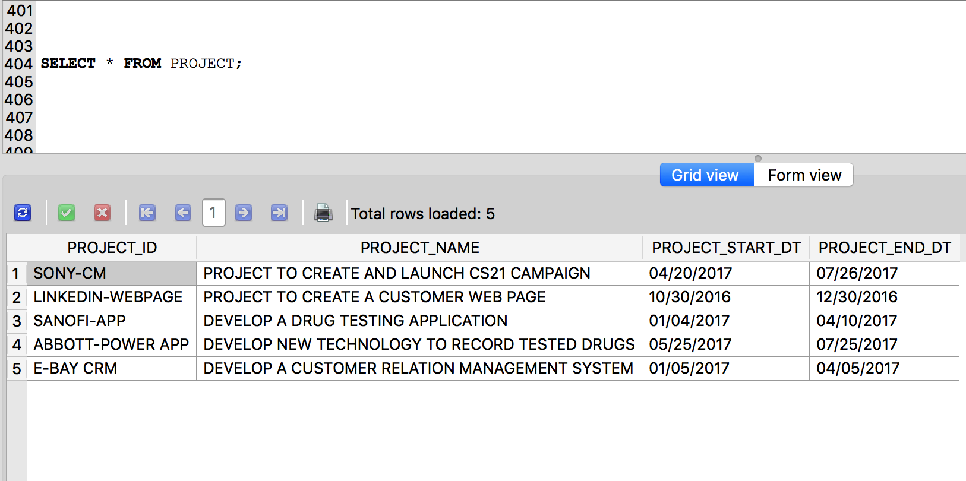

## **3. DEPARTMENT**

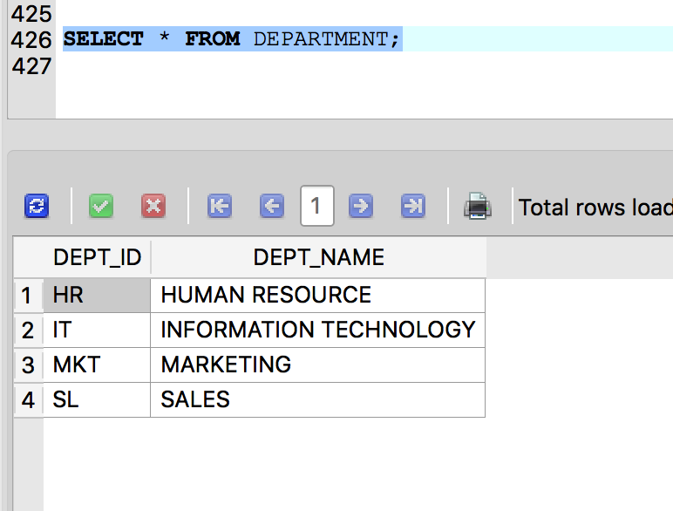

## **4. WORK**

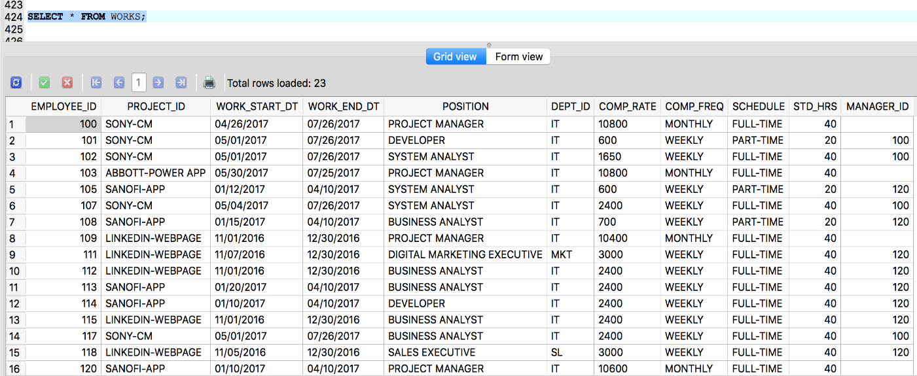

## **5. PROJECT ROLE**

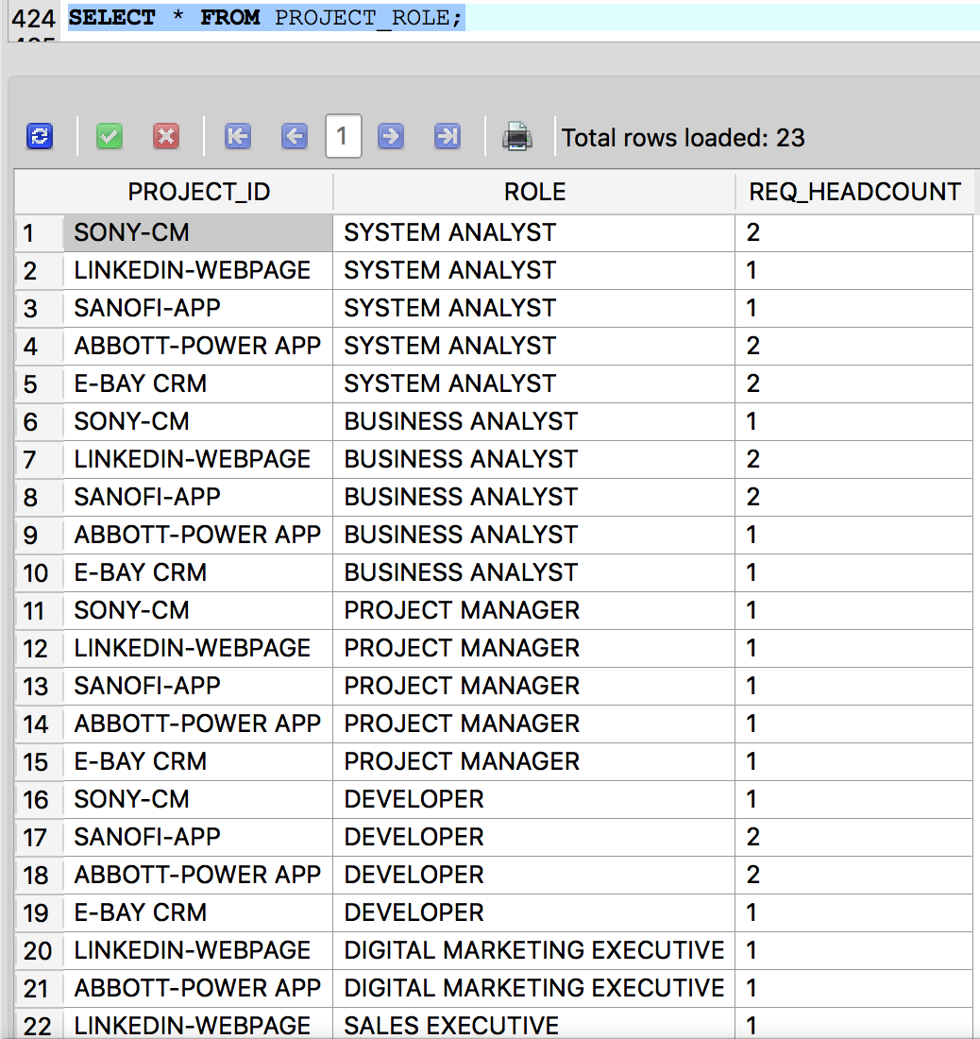

## **6. PROJECT STATUS**

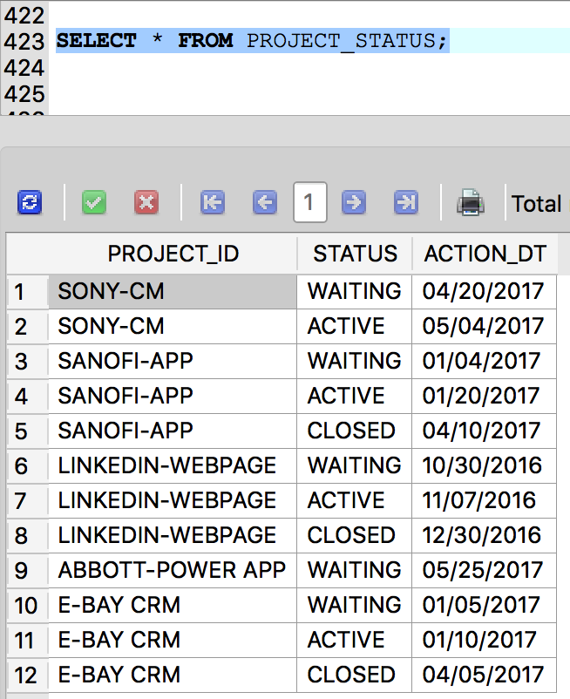

## **7. PERFORMANCE**

## **8. LEAVE**

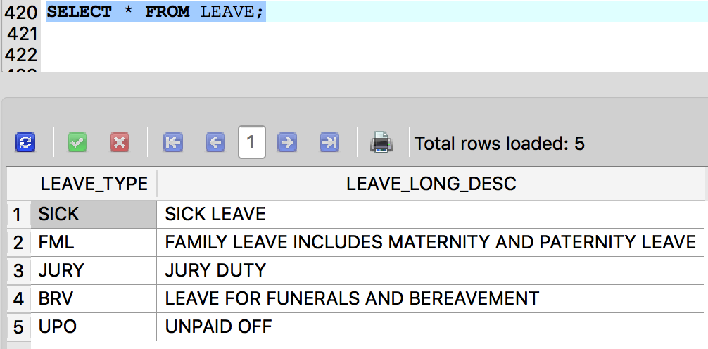

## **9. HOURS WORKED**

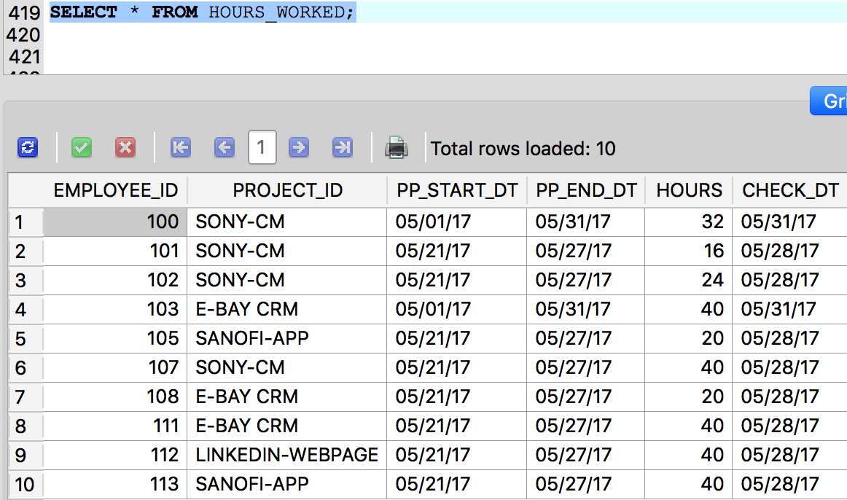

## **10. EARNING**

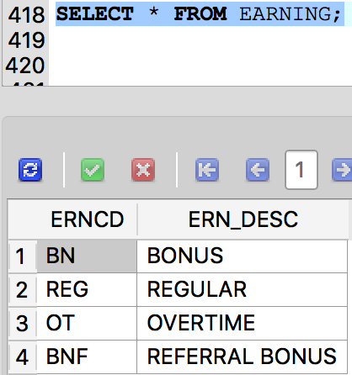

## **11. DEDUCTION**

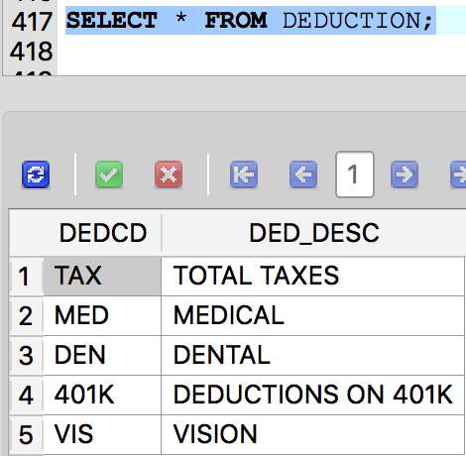

## **12. ABSENCE**

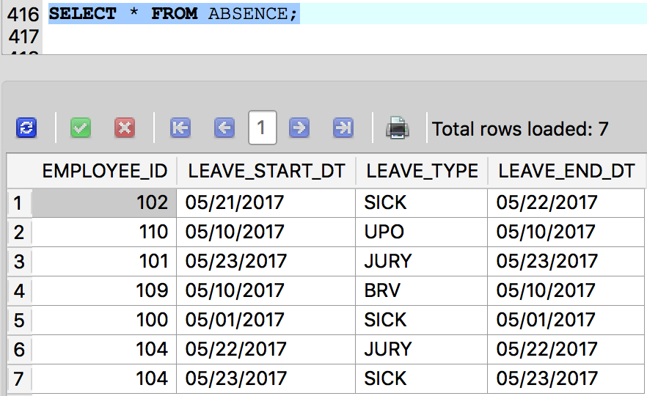

## **13. PAYROLL EARNING**

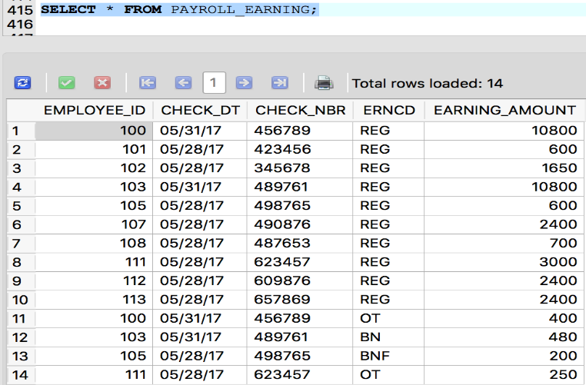

## **14. PAYROLL DEDUCTIONS**

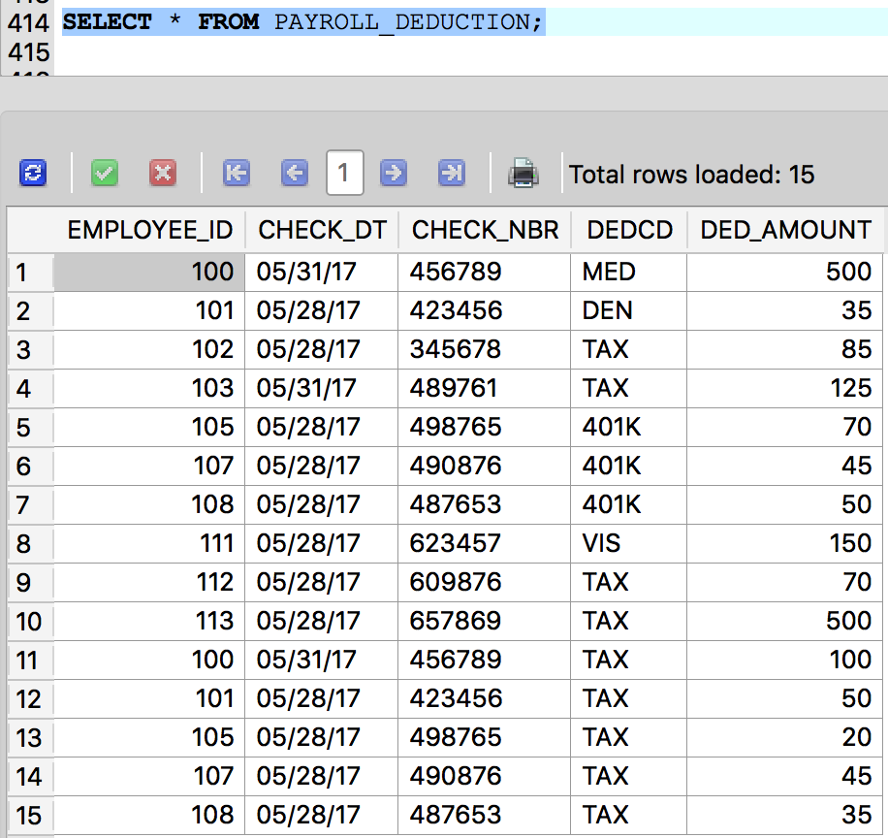

## **15. PAY DATA**



UPDATE AND DELETE QUERIES

1. UPDATE EMPLOYEE SET REFERRAL_SOURCE = 'CAREER-SITE' WHERE REFERRAL_SOURCE = 'OTHERS';

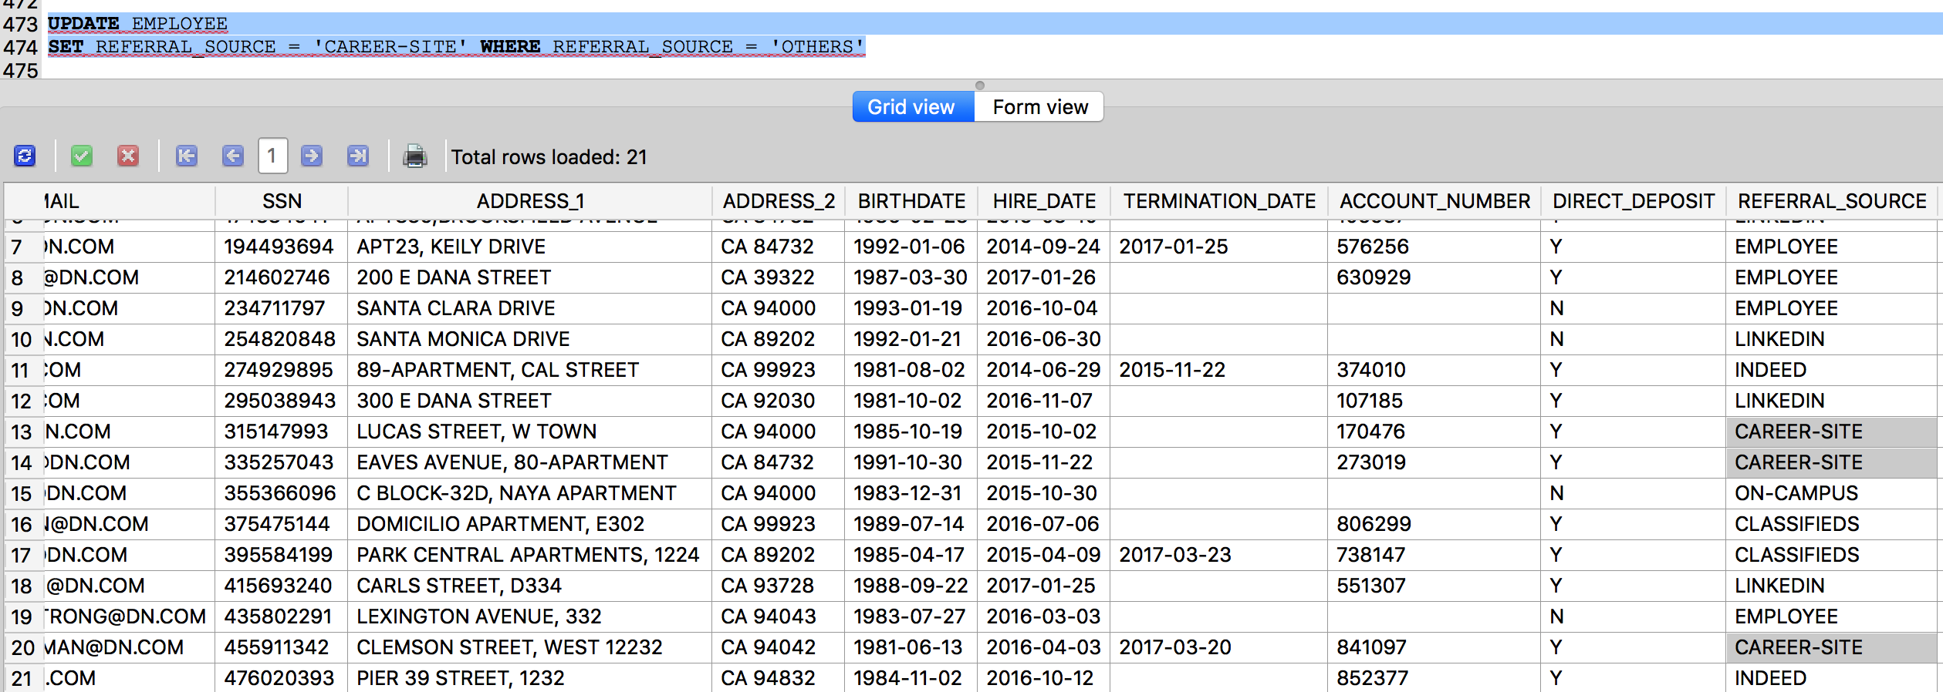

2. UPDATE WORKS SET COMP_RATE = CASE WHEN 1.1 * COMP_RATE < 2500 THEN 1.1 *COMP_RATE ELSE 1.05 * COMP_RATE END

WHERE COMP_FREQ = 'WEEKLY';

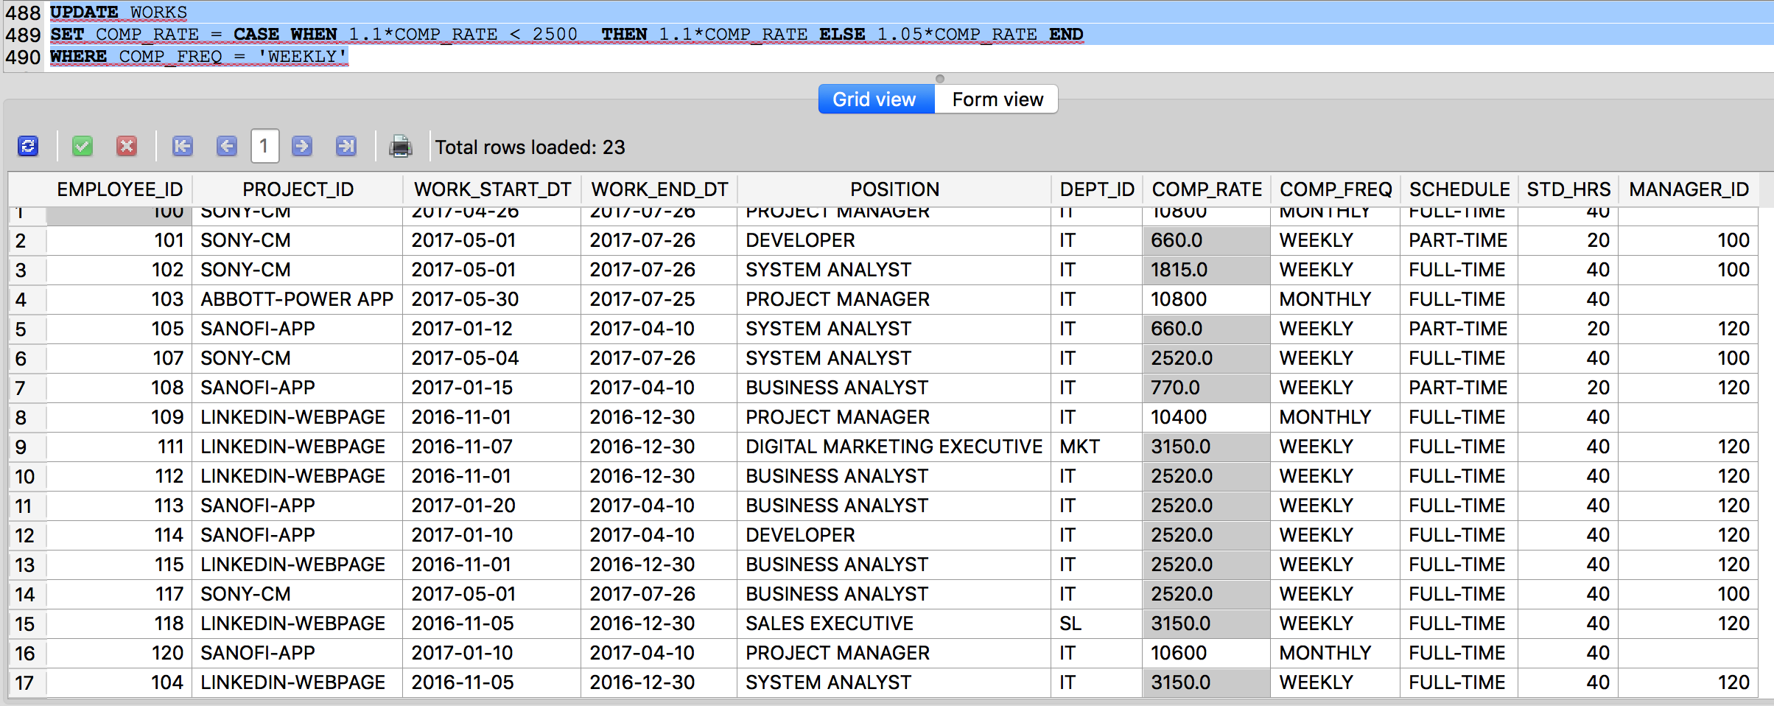

3. DELETE FROM PROJECT_ROLE WHERE PROJECT_ID = 'ABBOTT-POWER APP' AND ROLE = 'SALES EXECUTIVE'

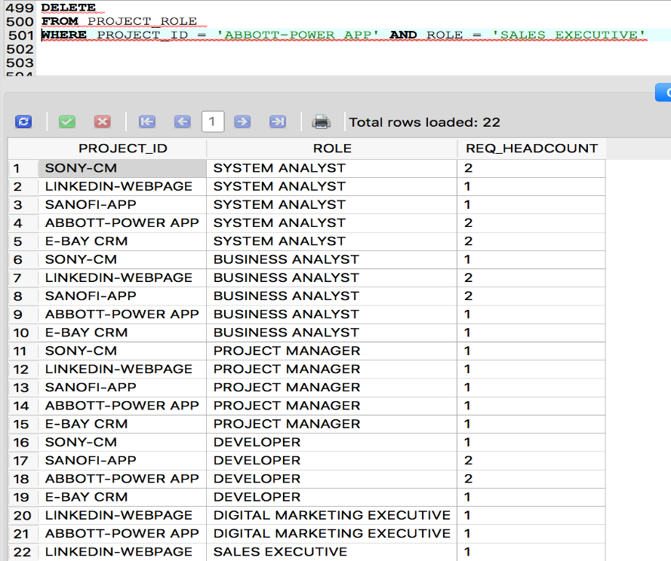

Business Metrics

## **TIME TO FILL IN POSITION**

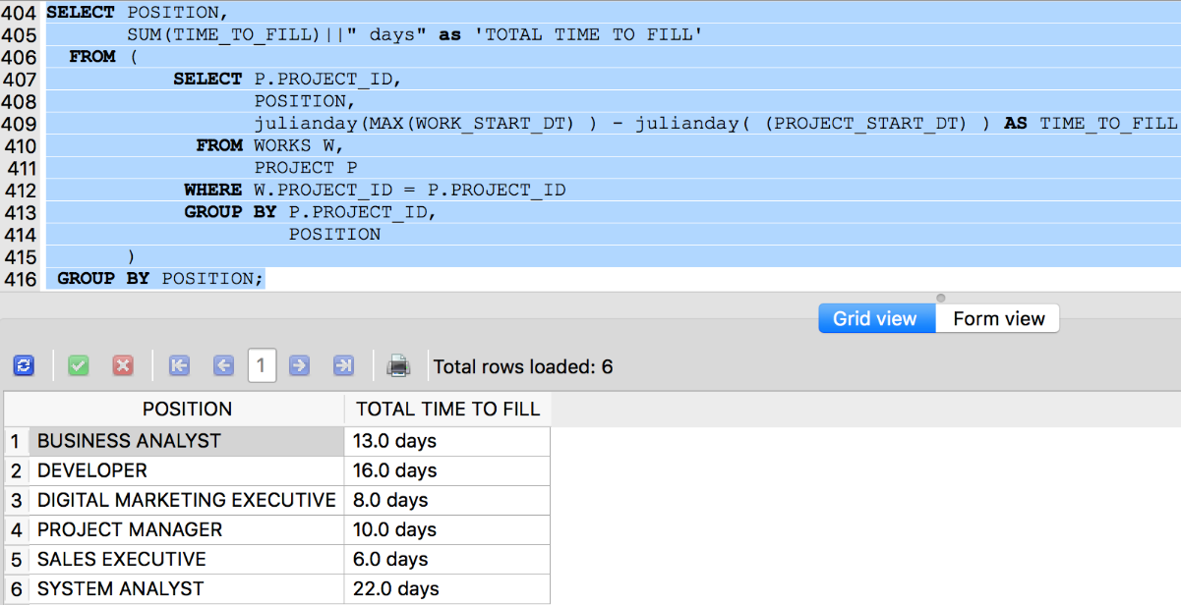

## **BENCH TIME CALCULATION WITHIN PROJECT ALLOCATIONS**

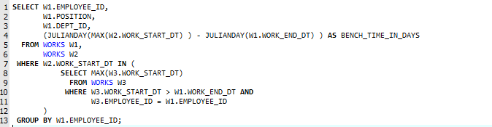



## **BENCH TIME CALCULATION AFTER HIRED AND PROJECT ALLOCATION**

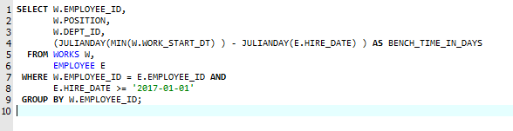



## **REFERRAL SOURCE**

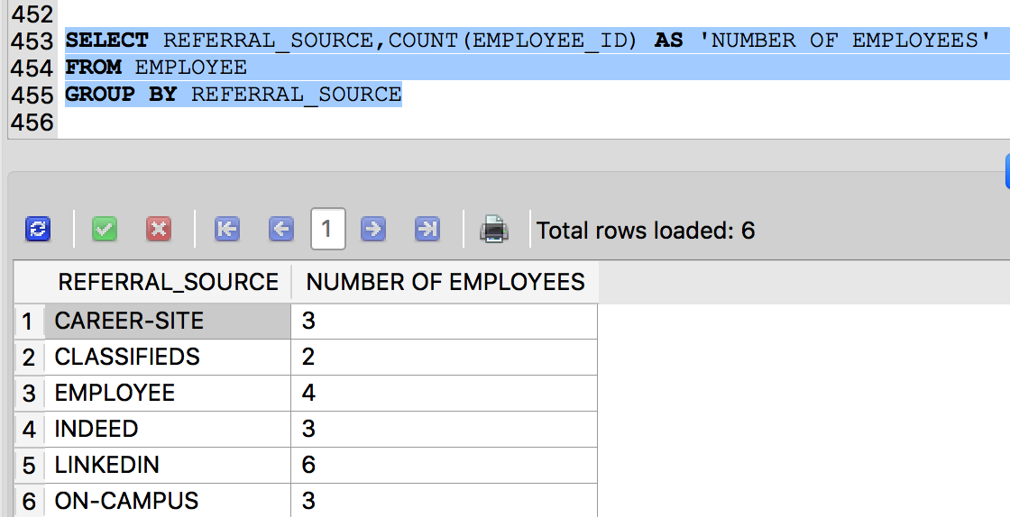

## **REFERRAL SOURCE OF TOP PERFORMING EMPLOYEES**

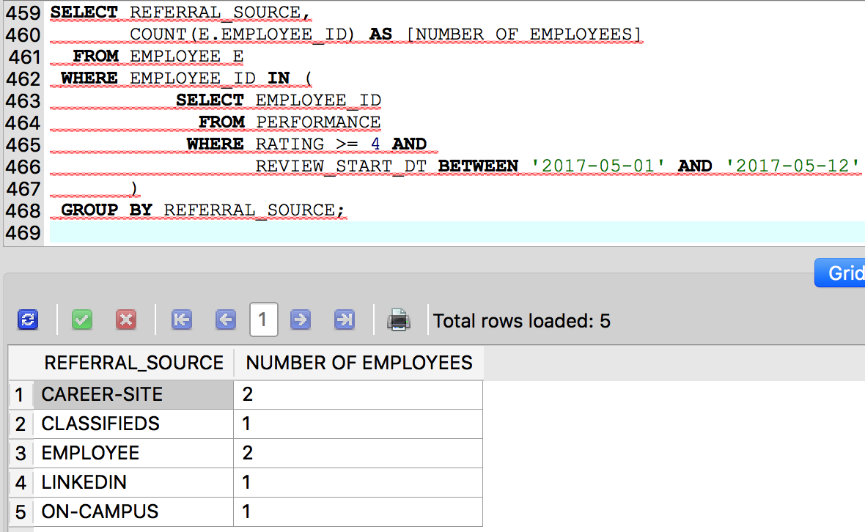

## **REASON FOR RESIGNATION**

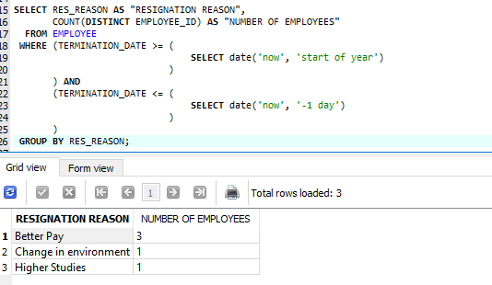

## **UTILIZATION**

## **PERCENTAGE OF UTILISATION OF EMPLOYEE IN THE COMPANY**

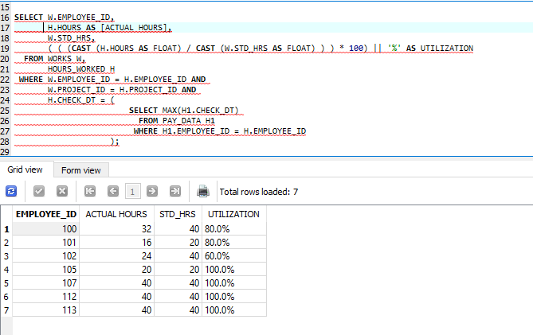

## **PERCENTAGE OF UTILIZATION OF TIME SPENT FOR A PROJECT**

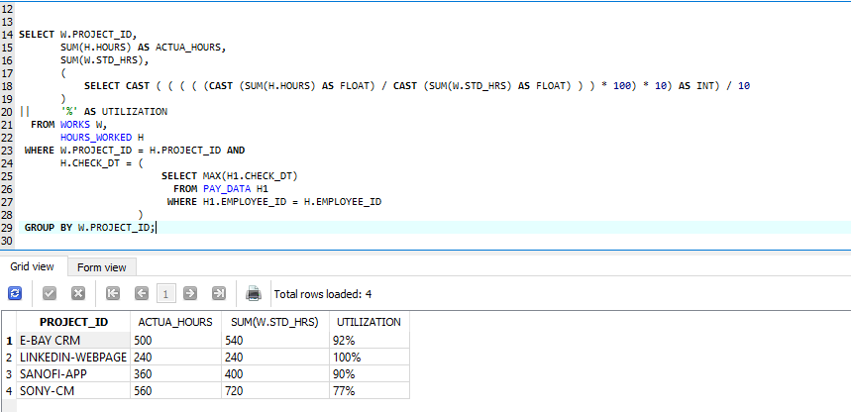

## **SALARY EXPENSE FOR EACH PROJECT FOR LAST PAY PERIOD**

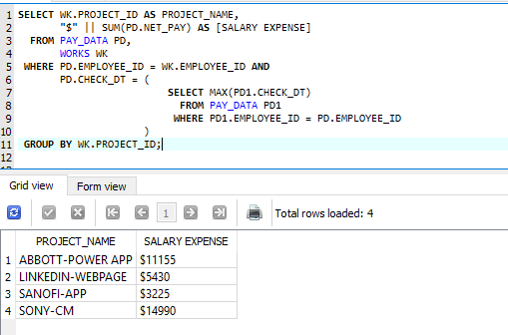

## **Summary**

**Experience:**

* **Scoping:** Working on this project was an enriching experience as we explored and learnt a lot through it. Firstly, we started with a huge business application which we had to scope down later on. We found it little challenging as we needed to fit main aspects of human capital management system into very few objects but positive side of this was that we learnt a very important skill of scoping the project.
* **Estimation:** Another important project management skill that we learnt from this project was estimation. We had roughly gauged the efforts required for each part of the project. However, we underestimated the efforts required for few tasks, especially the task of preparing the test data. We learnt how to proactively estimate tasks.
* **Designing:** We were familiar with SQL and database basics but we knew little about schema designing. UML and normalization taught us basic fundamentals of schema designing and how to apply them in real world.
* **Metrics:** Through metrics we got a very different perspective of looking towards data. In the beginning itself we came up with many metrics out which we selected few important ones which are actually used in businesses.

Overall this project tested our scoping, estimating, designing and analyzing skills.

**Hardest Part of the project:**

Nothing was hardest, but as compared to other tasks we found scoping and preparing test data little bit cumbersome.

**Problems & Solutions:**

* **Test Data:** Creating test data and making it consistent throughout the database was a tough task.

We thought thoroughly through it and prepared scripts accordingly. Because of the scripts we did not have to manually change any data. We just used excel to create scripts and scripts to modify the data.

* **System challenges:** The sqlite database did not support many of the functions such as TO_DATE, TO_CHAR, ALL etc. Also, date format of database was different that the date formats in our test data. We initially thought that we can easily use TO_DATE function to convert one date format into other but while working we realized that sqlite did not support those functions. We explored and eventually found out the functions which were compatible with sqlite.

So before starting any project it is really important to understand the capabilities and limitations of the system we are going to work on.

**Methodology:**

If we were to do this project again, we will spend little more time on UML. We will trace each and every cardinality thoroughly so that there won’t be any problem in future. We can further improve the design of hours_worked and pay data table.

**Suggestions:**

We believe that it would have been better if we would have got opportunity to use the tools which are widely used in the industry such as Oracle, SQL Server, Hive.